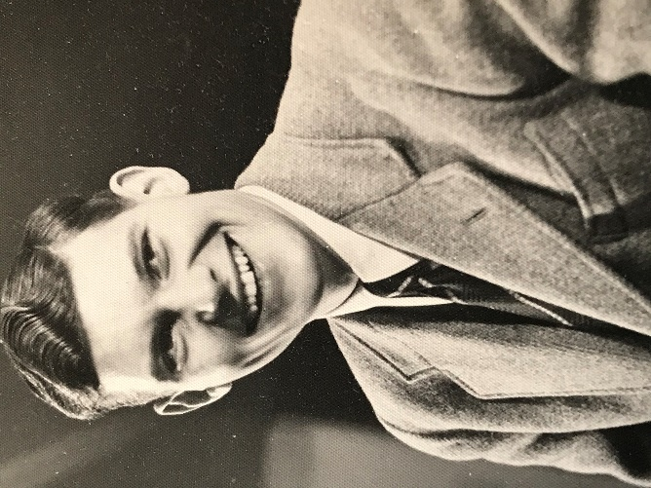
Geoffrey Cecil Kipling Pugh (1927-2020) was born in Camberley, and grew up in London and Bridgnorth in Shropshire. After leaving Tettenhall College in 1945, he spent two years National Service in the Army Intelligence Corps and was posted to Palestine. This gave him a lifelong interest in and affection for that region of the world.
Geoffrey did not take up his place at Trinity College at Oxford University to study History, rather decided to give all his time and energy to volunteer fulltime for the Christian charity, Moral Re-Armament (MRA). This led him to working in Italy, the USA, India, Sri Lanka, Pakistan, Australia and other places around the world. He used his skill at writing with many publications in these countries.
In 1965, he married Wendy Hoar. Much of their 55 year married life was spent at Tirley Garth, the MRA Conference Centre in Cheshire, where he gave unstintingly to the many hundreds who came there. He was Chair of the Trustees for many years and oversaw the sale of the estate, while living in the nearby village of Kelsall.
In retirement, Geoffrey and Wendy moved Ticehurst in East Sussex, before moving to join their daughter, Ann, and her family in Kent. Wendy predeceased Geoffrey by just five weeks and they are buried at St. Mary’s in Ticehurst.
Geoffrey is survived by his daughter, Ann, and his four much loved grandchildren.

